**Day 3 - API Integration and Data Migration**   
  
**Objective:** The focus for Day 3 is integrating APIs and migrating data into Sanity CMS to build a functional marketplace backend. Students will learn how to utilize APIs for reference, migrate data into Sanity CMS, and ensure compatibility with their templates. This approach replicates real-world practices and prepares students to handle diverse client requirements, including integrating headless APIs or migrating existing data from popular eCommerce platforms.  
  
"Day 3 - API Integration Report - [E-Commerce]

**Sanity  
  
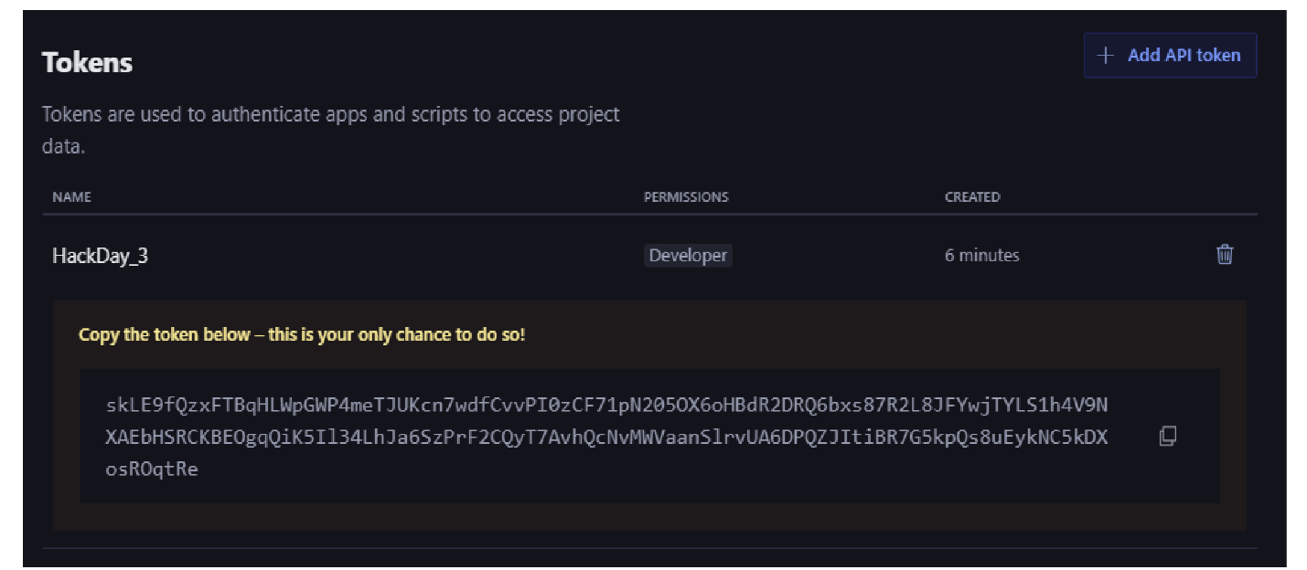  
  
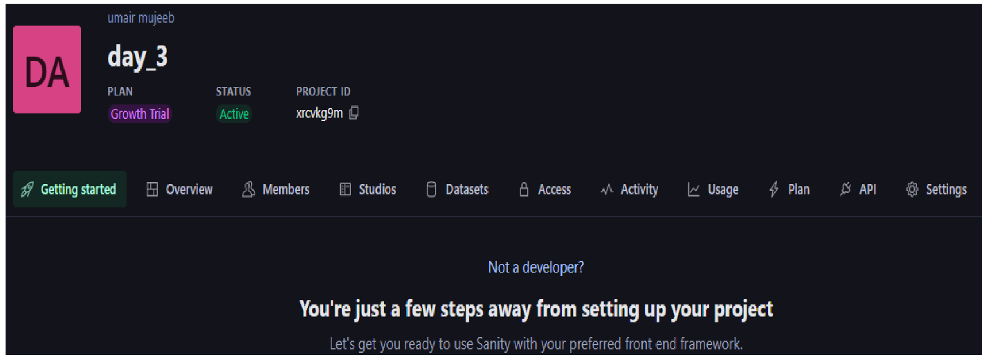  
  
Schema Type  
  
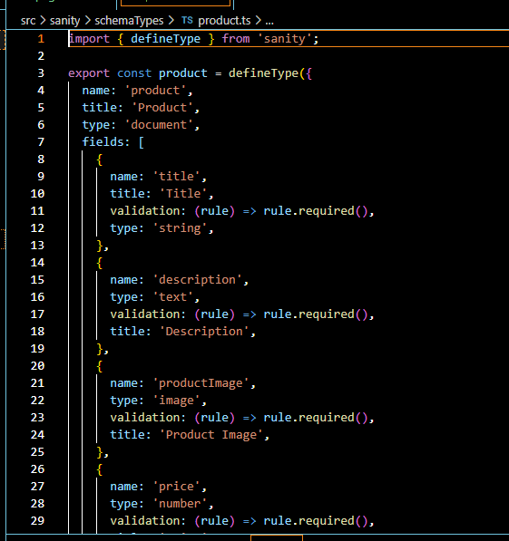**

**Import Data  
  
